PROTOCOL SERUM STOCKAGE
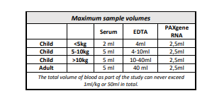
After clotting for 30 minutes, serum tubes will be centrifuged at 2000g for 10 minutes at room temperature. The supernatans needs to be split in three separate aliquots (Eppendorf) in equal volumes of at least 500µl per aliquot. Aliquots are labelled with an identical study number and are frozen at -80°C. Serum samples should be frozen at 1 hour after the blood was obtained

